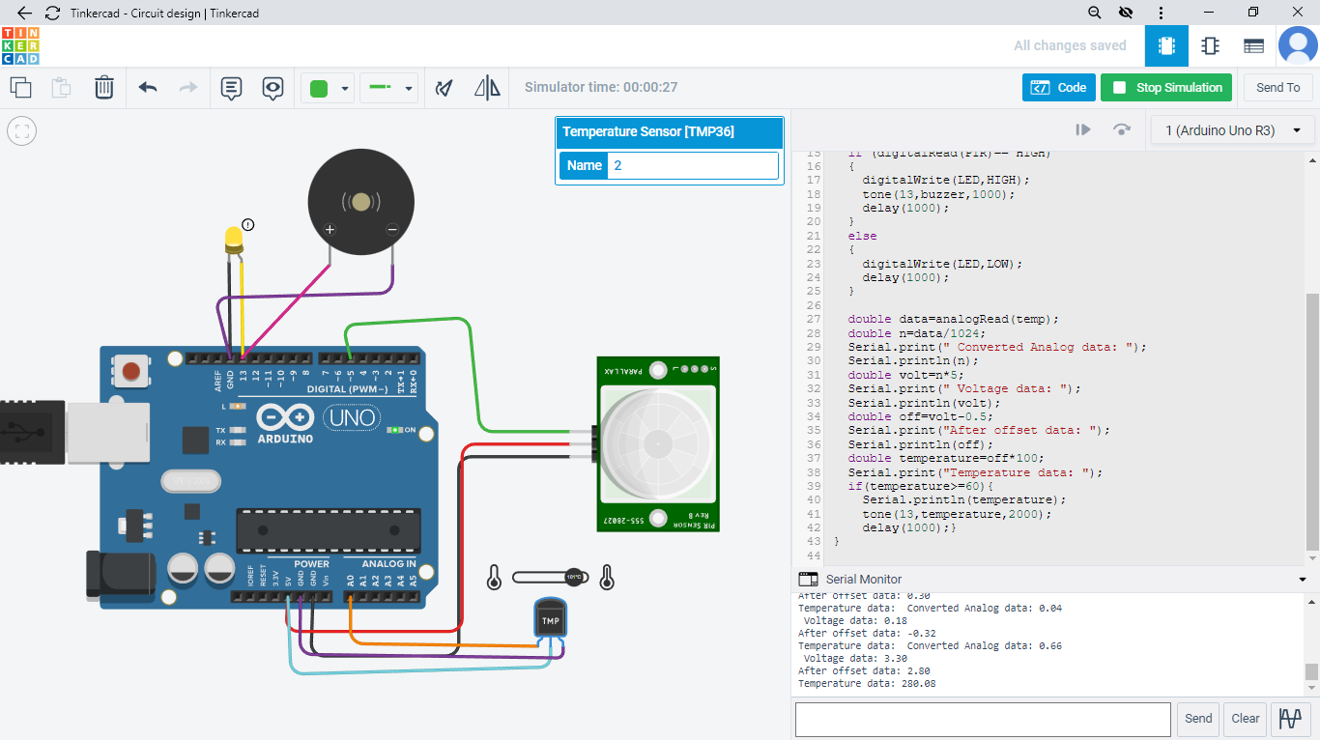

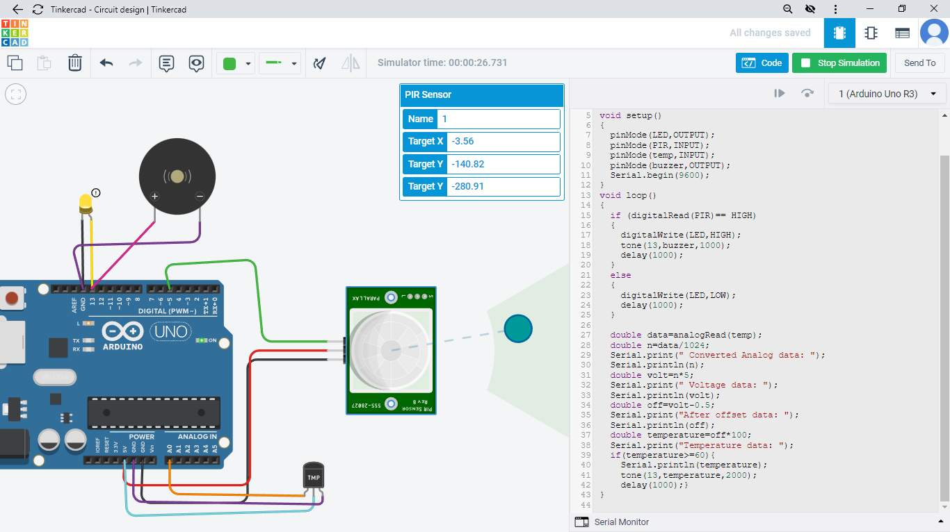

CODING :

int LED = 13;

int PIR = 5;

int temp = A2;

int buzzer = 13;

void setup()

{

pinMode(LED,OUTPUT);

pinMode(PIR,INPUT);

pinMode(temp,INPUT);

pinMode(buzzer,OUTPUT);

Serial.begin(9600);

}

void loop()

{

if (digitalRead(PIR)== HIGH)

{

digitalWrite(LED,HIGH);

tone(13,buzzer,1000);

delay(1000);

}

else

{

digitalWrite(LED,LOW);

delay(1000);

}

double data=analogRead(temp);

double n=data/1024;

Serial.print(" Converted Analog data: ");

Serial.println(n);

double volt=n\*5;

Serial.print(" Voltage data: ");

Serial.println(volt);

double off=volt-0.5;

Serial.print("After offset data: ");

Serial.println(off);

double temperature=off\*100;

Serial.print("Temperature data: ");

if(temperature>=60){

Serial.println(temperature);

tone(13,temperature,2000);

delay(1000);}

}